Ningaloo Turtle Program Volunteer Application Form
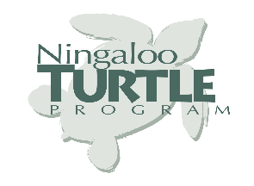
If you are interested in a 5 week position as a volunteer for the Ningaloo Turtle Program please forward this application form, your CV and a cover note telling us why have you applied to join the Ningaloo Turtle Program, to the NTP Coordinator at ningalooturtles@dbca.wa.gov.au, Fax: (08) 9947 8050 or Post: Exmouth Parks and Wildlife Service, PO Box 201, Exmouth, Western Australia, 6707 before 4:00pm (GMT+8), Friday 31st July 2020.

Before filling out application please ensure you have read the Volunteer Information Sheet
Title | Select item. | Nationality |  | Required.
Surname | Required. | First Name |  | Required.
Postal Address | Required. | Town or City |  | Required.
State | Required. | Country |  | Required.
Post Code | Required. | Email |  | Required.
Mobile Phone | Required. | Home Phone |  | Required.
Date of Birth | Required. | Gender |  | Select item.
Do you have a full manual Australian Driver’s licence? |  |  | Select item.
Do you have a senior 1st Aid qualification? |  |  | Select item.
Are you applying to volunteer with another person? |  |  | Select item.
If yes then other person’s name |  |  | Required.
If studying, where and what are you studying?
Are you on workers compensation or sick leave?
Do you suffer from any illnesses or allergies?
Do you have any pre-existing medical conditions or medical history which program staff may need to be aware of?
Is there any reason you would be restricted in some areas of volunteer work (e.g. Knee injury)?
I have read the Volunteer Information Sheet and understand what is required of me as an NTP volunteer. I agree to the terms and conditions of the NTP program.

