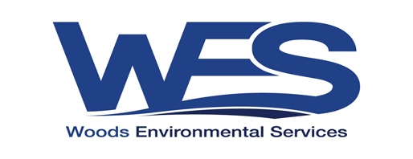
Position Description
Crew Member – Enviro Crew

Reports To | Direct Reports
Crew Leader – Enviro Crew | Nil

Responsibilities
- Operate within the Woods Environmental Services policies and procedures
- Taking care of own and colleagues Health and Safety through identification and reporting of hazards and active involvement in improvement initiatives.
- Delivery of a variety of Natural Resource Management activities for various clients.

Key Skills Required
- Taking care of own and colleagues Health and Safety through identification and reporting of hazards and active involvement in improvement initiatives.
- Operate within the Woods Environmental Services policies and procedures, OH&S procedures, Task Risk Assessments and Environment Management System
- Sound knowledge of native vegetation, plant ID and weed control and revegetation techniques.
- Knowledge of native grasslands in Melbourne’s West would be advantageous for west crew.
- Projects to be completed on time and to the required standard and within financial constraints.
- Maintain accurate records of activities including cost control and daily logs.
- Follow agreed health and safety procedures and be willing to receive and provide constructive feedback.
- Be actively involved in identifying, promoting and implementing initiatives that improve health and safety.
- Prompt reporting of near misses or incidents

Skills & Qualifications
Essential:
- Significant workplace experience
- ACUP and/or AGvet
- Level 2 First Aid
- Australian Driver’s License
- OH&S White/Red Card
- Physically fit

Advantageous:
- Relevant tertiary qualifications-
- Chainsaw operations
- Construction OHS Induction (White/Red Card)
- High Risk Licenses
- 4x4 trained
- Remote first aid
- IRATA ropes training

Salary Range
- We offer an attractive, above award package which will be dependent on experience and expertise of the selected candidate.

