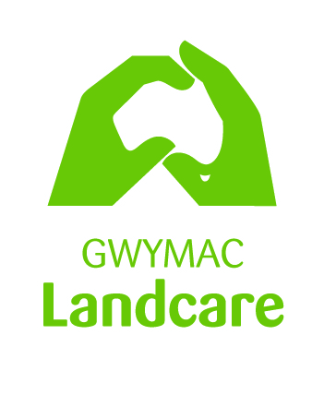
Gwymac Landcare Coordinator

Position Title | Landcare Coordinator
Employer | GWYMAC (Gwydir & Macintyre Resources Management Committee Inc.
Location | Inverell Shire and Surrounds
Employment terms/Remuneration | Casual Position, 18 hours per week (normal work hours – Three days per week).  $25 to $30 per hour (Depending on experience), plus superannuation with a performance review in 3 months from starting date.
About Gwymac | GWYMAC Inc. is a not for profit organisation network supporting local Landcare groups with on-the ground works for biodiversity restoration and conservation as well as promoting education communication and sustainability within the Inverell District and surrounds.
Position Role | The Landcare Coordinator will provide support to the Gwymac Landcare team to engage with the various groups across the region, to raise awareness, and improve sills in managing a diversity of agriculture and environmental issues.  Duties include:  - Coordinate field days and extension events, facilitate Landcare group meetings.  - Undertake planning and secure resourcing through project grants and other sources.  - Project administration including monitoring and evaluation, reporting on project outcomes.  - The Landcare coordinator will also manage their workloads effectively. Attendance at meetings outside of normal work hours may be required. Travel around the region and infrequent travel including overnight stays may also be required.
Reporting/Supervision | Position reports to the GWYMAC Executive Committee
Selection Criteria | Please address each of the following criteria as a short separate paragraph:  - Demonstrated well developed written and oral communication skills, including competence in the use of Word, Excel, publisher, email, internet and social media.  - Proven ability in record keeping and report writing.  - Demonstrated ability to work independently and work effectively in a team environment.  - Effective interpersonal skills, including demonstrated ability to work with community groups, group facilitation and negotiation.  - Ability and willingness to work occasionally outside office hours to contact Landholders, attend community group meetings and workshops.  - Current Drivers Licence.
Desirable Criteria | - Experience in Natural Resource Management, Sustainable Agriculture or similar.  - Proven ability in all aspects of Project Management.  - Demonstrated experience in grant writing.
Applying for the Position | To apply. Please provide the following:  - Brief covering letter  - Address selection criteria and desirable criteria  - Your current CV/Resume which should include current contact details of two referees  - Applications should be emailed to: admin@gwymaclandcare.net.au
Closing Date | Applications must be received by COB Monday 28th September 2020

